Minutes of the NIAS Fellows Association General Meeting 2023
Date of Meeting: June 8 2023
Location: NIAS Conference Room and online via Zoom
Agenda
1. Opening of the General Meeting
2. Minutes of the last General Meeting in 2022
3. Financial Report 2022
4. Golestan update. Report by Franjo Weissing & Joe Bauman
5. This year at the NFA. Report by Roxane Farmanfarmaian
6. Presenting NFA gift to NIAS
7. This year at NIAS. Report by Bernike Pasveer
8. Other business
9. Closing

1. Opening
Bernike Pasveer is welcoming all present in the NIAS Conference Room and online. Philip Spinhoven, Chair of the NIAS Fellows Association, opens the general meeting, welcoming all for the hybrid meeting (both online and on site). The members of NFA Board introduce themselves. There are no points to be added to the agenda from the general membership.

2. Minutes of the last General Meeting in 2022
No queries or comments. The minutes are approved.

3. Financial report
The financial report was made public before the meeting. Emmanuel Berger (treasurer) presents the main findings.
In 2022 there were 20 new alumni and the NFA had an income of €1.925,- out of the membership fees. If the NFA has 20 new members each year it covers the costs.
The bank fees are about €200,- each year. The NFA will move to another bank (when the statutes are formalized by the notary). The auditing committee has approved the financial report. We are looking for new members for the auditing committee. It takes 15 to 20 minutes per year. No experience needed in bookkeeping. Please contact Philip Spinhoven

4. Golestan update by Franjo Weissing & Joe Bauman
Franjo: As there was no suitable applicant last year it is possible to fund 2 fellowships the coming year. To find a suitable applicant Golestan will look at the NIAS Lorentz applicants and will select one or two fellows of their own within the applicants. It could also be a team consisting of one life science fellow and one social science fellow.
Joe Bauman: 2022 was a difficult year for investments, but we preserved assets. The relocation of the Rosegarden to the Fellows House in Amsterdam was a big expense and costed €24.000. The portfolio of investments (open information) at ABN AMRO consists of about 10 funds that cover a variety of businesses.

5. This year at the NFA. Report by Roxane Farmanfarmaian (Secretary NFA)
An online cohort meetup was organized by Kahliya on August 30. There was a lot of catching up to do about grants, careers, and family. NFA wants to see if they can organize meetups for more cohort groups. Online meetups or gatherings in cities with a lot of fellows (New York (done before)/ London to be organized). Let us know if you want to participate.
10 Alumni returned to the Fellows House for summer stays, among them some fellows who were at NIAS during COVID and could now experience the vibe of the Fellows House. The summer stays have a different feel from the academic year: quieter and a spirit of intellectual time.
6. Presenting NFA gift to NIAS
Arne Hendriks tells about the gift made for the 50th anniversary of NIAS. It is called Swarm and consists of bird’s nests placed in the stairway of NIAS. Symbolizing NIAS as a place where you come back to. It is a work in progress and it might grow with the years. Arne: pick your own nest and consider it yours.

7. This year at NIAS by Bernike Pasveer
- After COVID it was great to have everyone back at the institute. Staff-wise NIAS was in a precarious situation but our new institute manager Marlous was very energetic and we are now back on track.
- The conference is postponed to October. Luckily most speakers still want to come and we are looking forward to an interesting conference on belonging and mobility. Please come from 18 to 20 October to Pakhuis de Zwijger.
- In the coming year NIAS will have 4 Safe Haven fellows: 2 Ukrainian, a Russian and a Belarusian fellow.
- We are also looking to diversify our fellow's groups and would like to attract more fellows from the global south. We had our procedures looked into for barriers and we are looking for networks to help us in this regard.
- We have a full summer with 10 alumni stays and SIAS visiting us in July.
- During the opening of the academic year NIAS will present the first book of a book series we will publish with Amsterdam University Press: Academic Freedoms: What is at Stake? (Academische vrijheden: wat staat er op het spel?, Amsterdam University Press) edited by Lukas M. Verburgt and NIAS Director Jan Willem Duyvendak.
- One final question: NIAS needs reviewers for the proposals of future fellows, please sign up with Bernike > bernike.pasveer@nias.knaw.nl
8. Other business
No further questions or comments.

9. Closing
The chair thanks all attendees and introduces the next part of the programme, the Uhlenbeck Lecture by alumnus Naomi Ellemers.
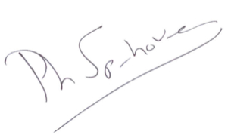

Signed Philip Spinhoven (Chair NFA)

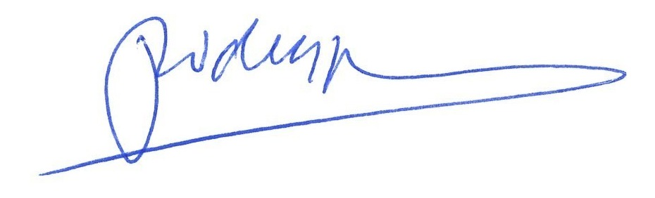
Signed Jan Willem Duyvendak (Director NIAS)

